@startuml

class RandomEventTable {
+int inEvent
-int eventKey
-int eventLength
-String eventDescription

+RandomEventTable(int inEvent)
+int EventKey()
+int EventLength()
+String EventDescription()
}

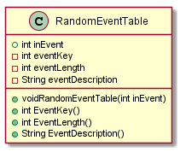
@enduml

